 Pangani Basin Water Board 
Hydrological Bulletin April 2026
2025

- RAINFALL TRENDS
Hydrological condition of month April 2026 registered some of the extreme event in areas within the Pangani Basin. Rainfall events especially in the upper catchment of Kikuletwa brought scary moments with some of residents in the basin left with no home. Substantially below average rainfall was only observed in five rainfall stations (which particularly located in Arusha City, Tanga City, Segera, Nyumba ya Mungu and Kilifi) out of sampled 33 representative rainfall stations whilst the remaining received a relatively higher than average rainfall as forecasted by Tanzania Meteorological Authority (TMA).

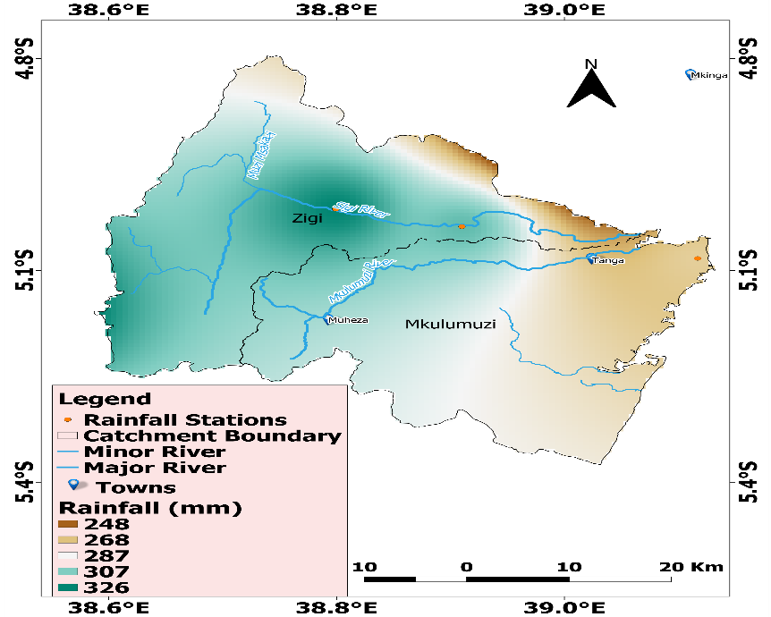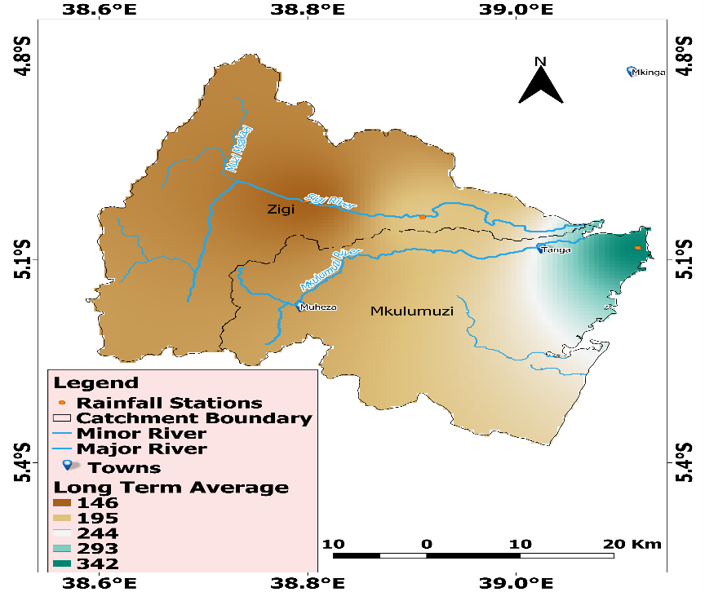
Figure 1&2: Rainfall distribution in Zigi Catchment for the month of April 2026

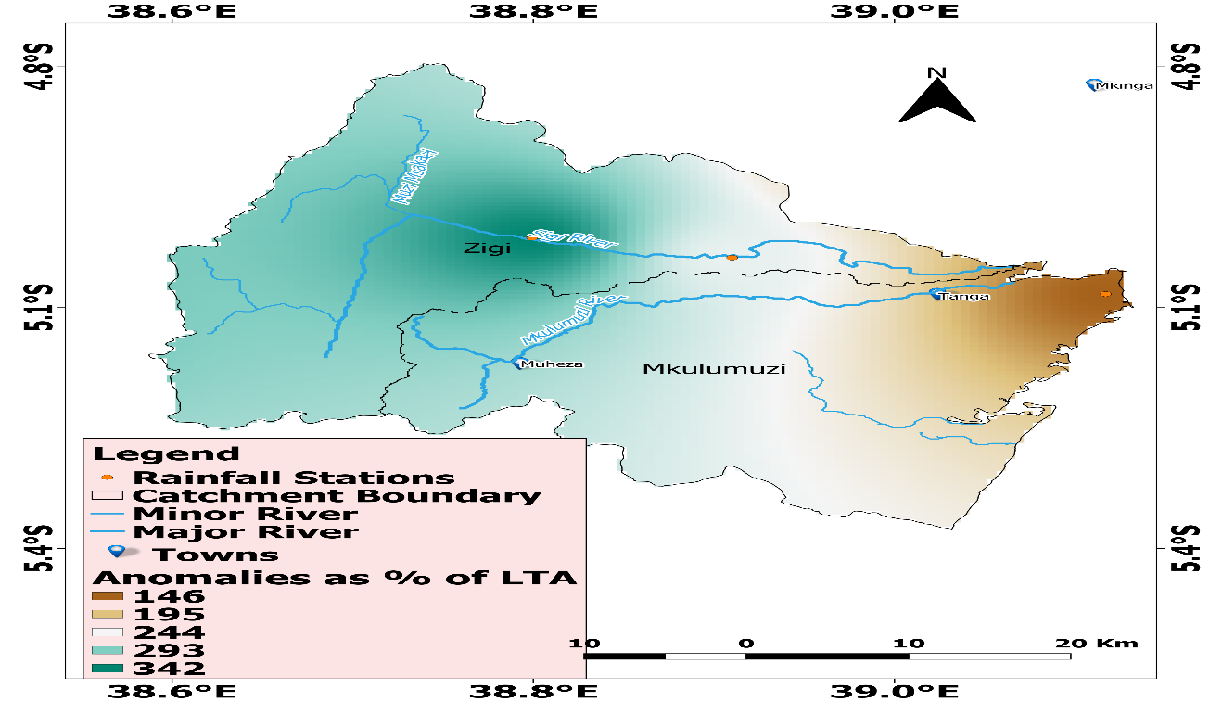
Figure 3: Rainfall anomalies in April 2026 presented as percentage of Long-Term Average in Zigi Catchment

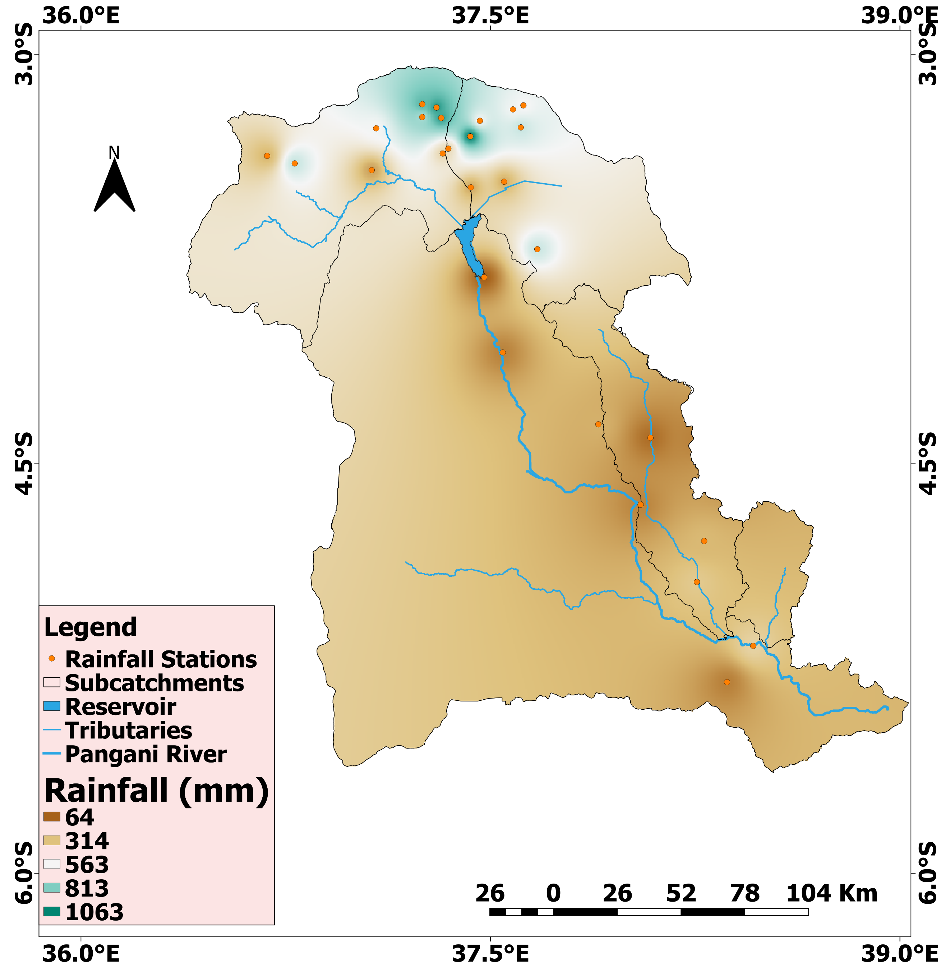

Figure 4: Long Term Average rainfall for month April in Pangani Main Stem for last 10 years

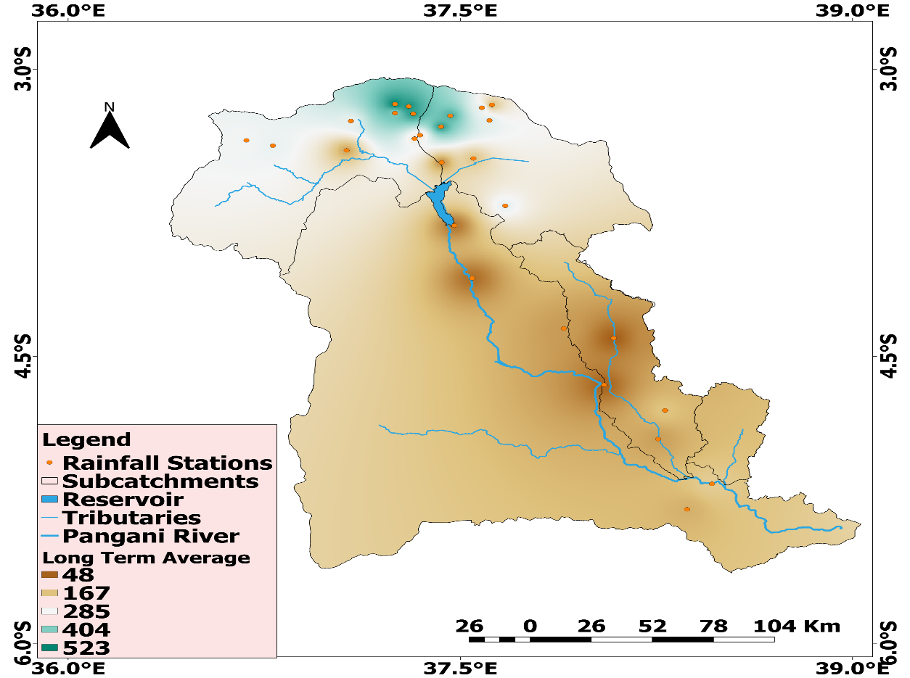
Figure 5: Pangani Main Stem rainfall distribution in month April 2020
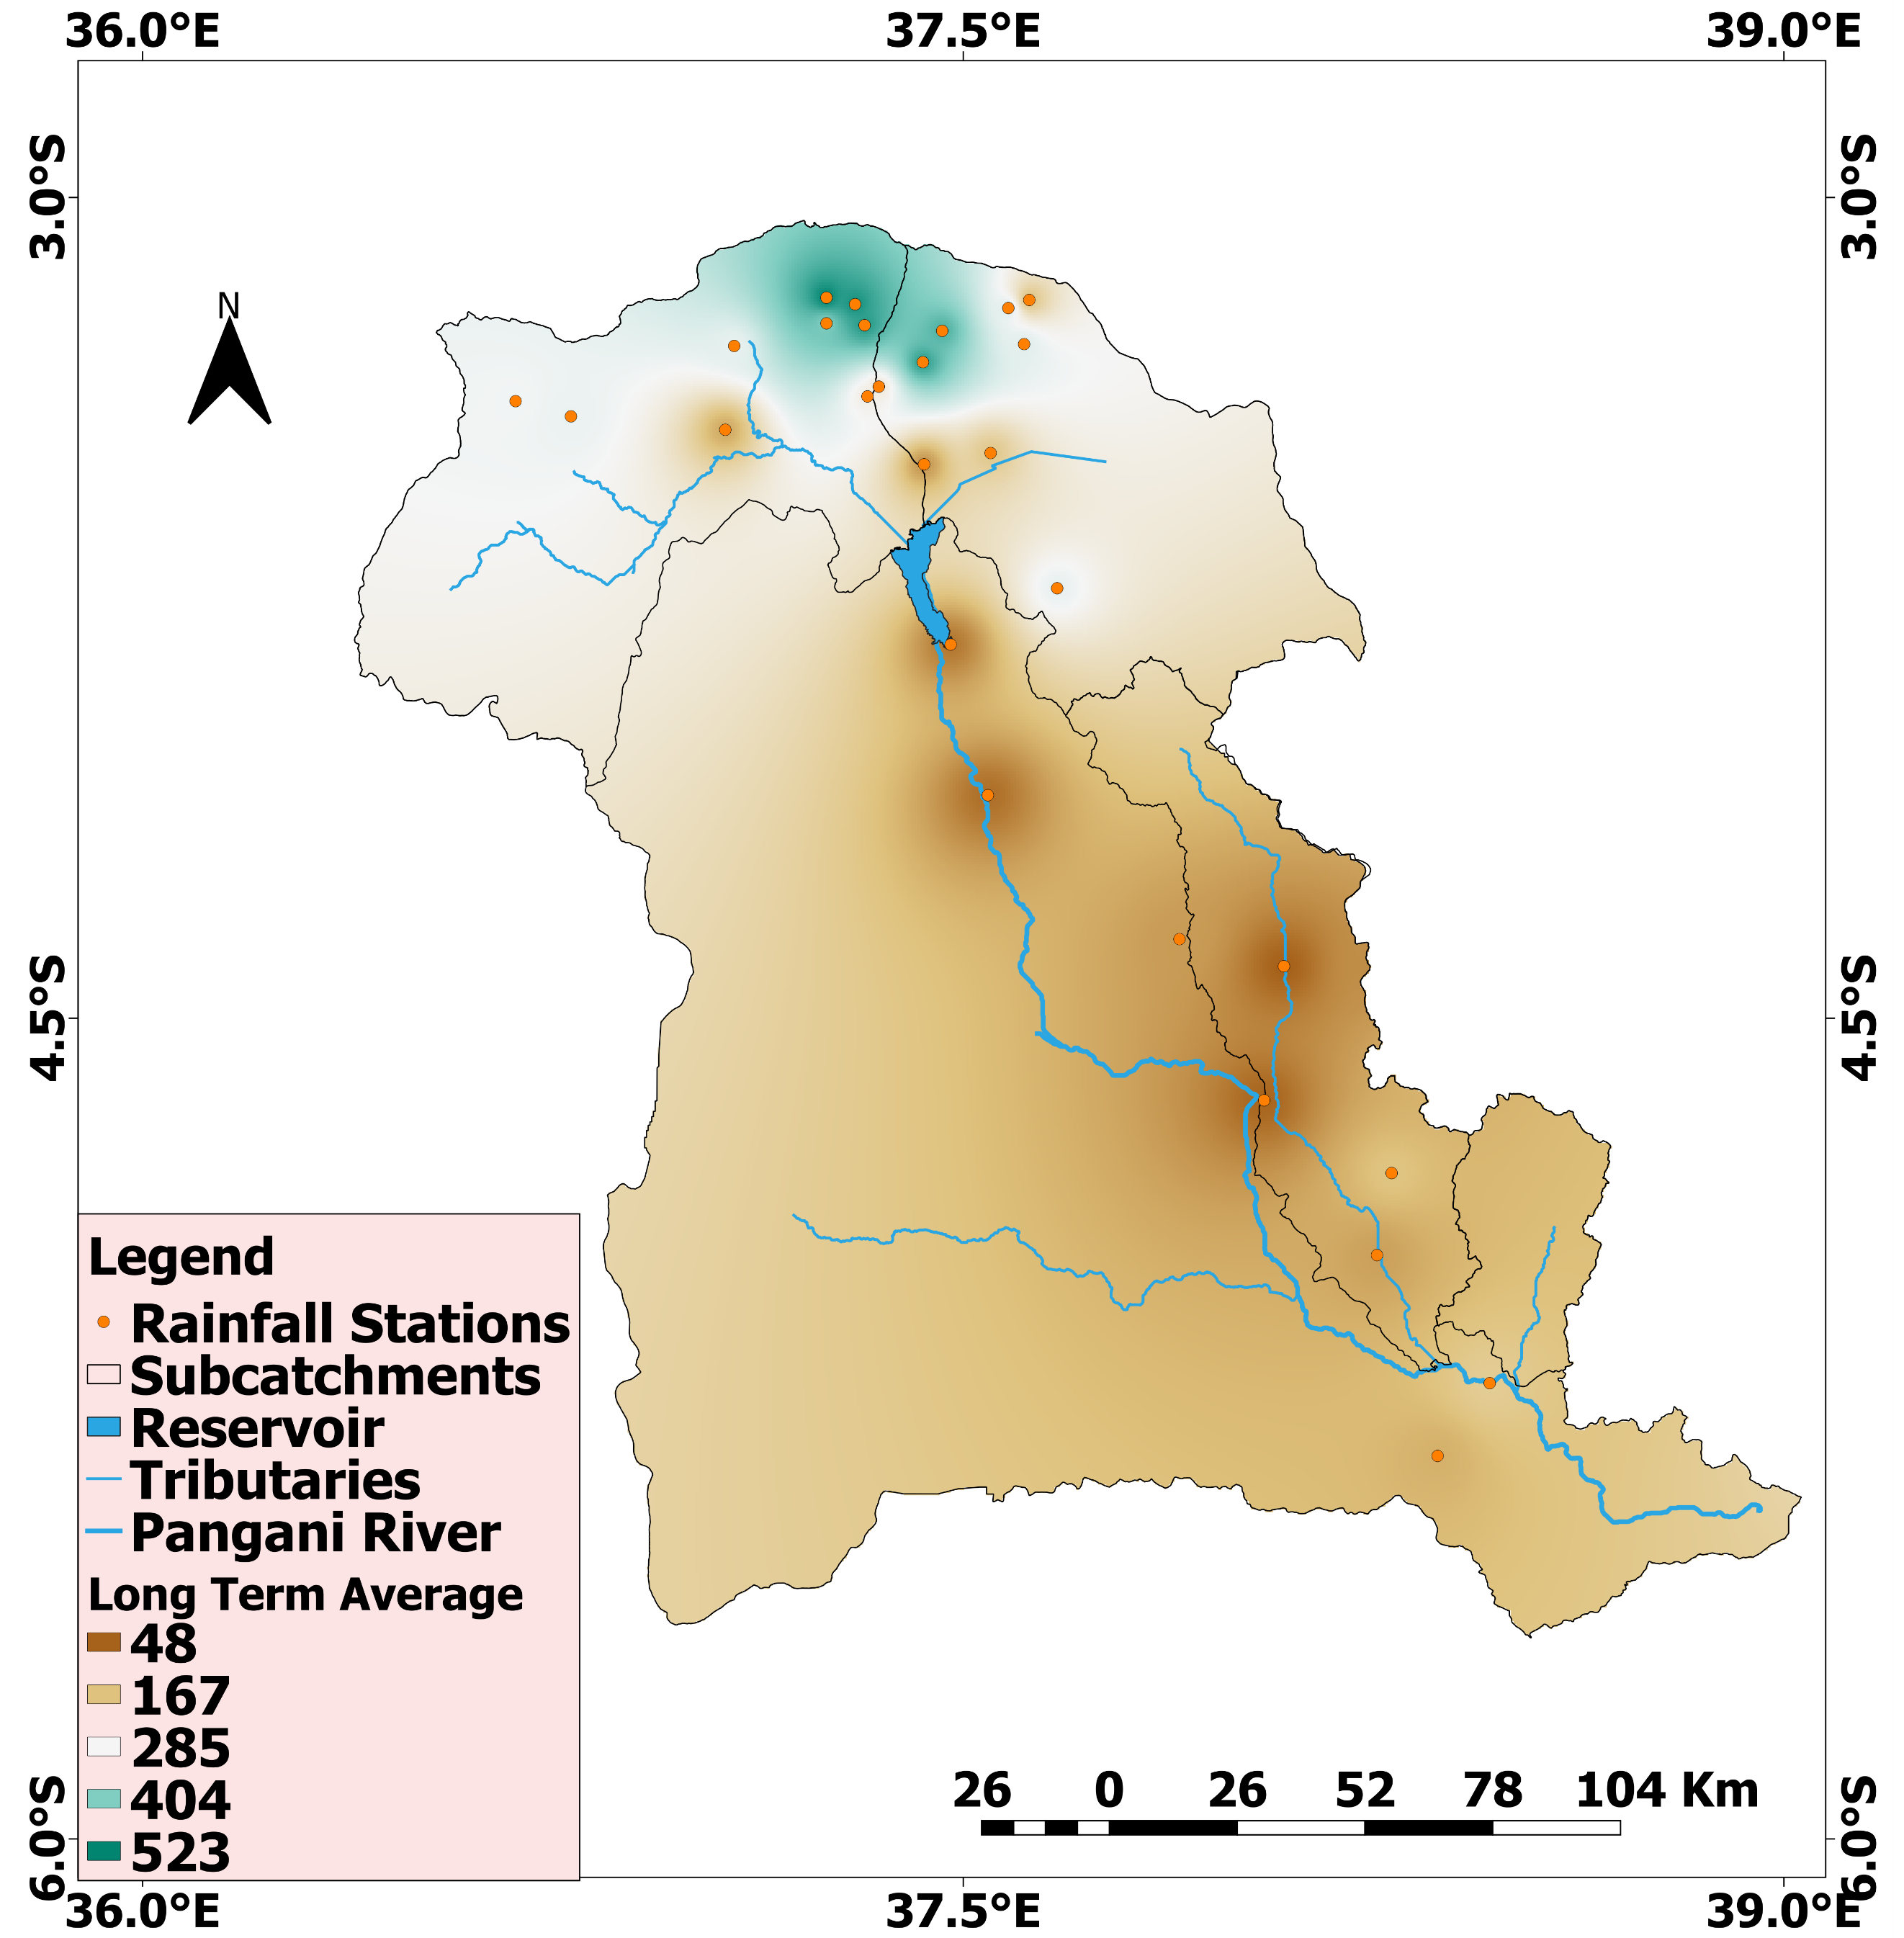

Figure 6: Rainfall anomalies in month April 2026 presented as percentage of Long-Term Average in Pangani Main Stem

- RIVER FLOWS AND RESERVOIR LEVELS
River flows were extremely high especially in the last 10 days of the month April 2026. Within the last 15 years, the month was the second wettest for Zigi (figure 9) and Kikuletwa (figure 7) river while being the third and fourth for Ruvu (figure 8) and Pangani (figure 10) rivers respectively. Reservoir level continued to be higher than their Long-Term Average. The Nyumba ya Mungu reservoir (figure 11) recorded its highest level of 689.43 masl on the 30th of the month. The Mabayani reservoir (figure 12) water levels were also above the average and it registered its monthly second highest value of 4.64m on the 20th of the month (the highest being 4.76m in 2004).

  - Flows hydrographs for selected rivers (from April 2026)
Figure 7: Kikuletwa River | Figure 8: Ruvu River
Figure 9: Zigi River | Figure 10: Pangani River (Korogwe)
  - Water level hydrographs for reservoirs
Figure 11: Nyumba ya Mungu Reservoir | Figure 12: Mabayani Reservoir

- CONCLUSION
In general, the month of April 2026 was very wet with a succession of frontal systems delivering persistent heavy rainfall across the Basin. River flows were substantially above average across the most parts of the Basin. However, hydrological anomalies events which triggered floods and landslides were associated by succession of rainfall events with higher intensities especially in the southern slopes of Kilimanjaro and Meru Mountains during the last ten days of the month April 2026. Yet, the water resources outlook for this year continues to improve.

About us
Pangani Basin is a transboundary Basin covering an area of about 58,400 km² of which 93% (54,600 km²) lies in Tanzania and the remaining 7% (3,800 km²) lies in Kenya. The Basin cut across four (4) regions including Kilimanjaro, Arusha, Tanga and part of Manyara (Simanjiro, Monduli and Kiteto) with a total of 24 administrative Districts Councils. The nine (9) catchments in the Pangani Basin are Kikuletwa, Ruvu, Mkomazi, Pangani Mainstem, Luengera, Zigi, Umba, Mkulumuzi and Msangazi.
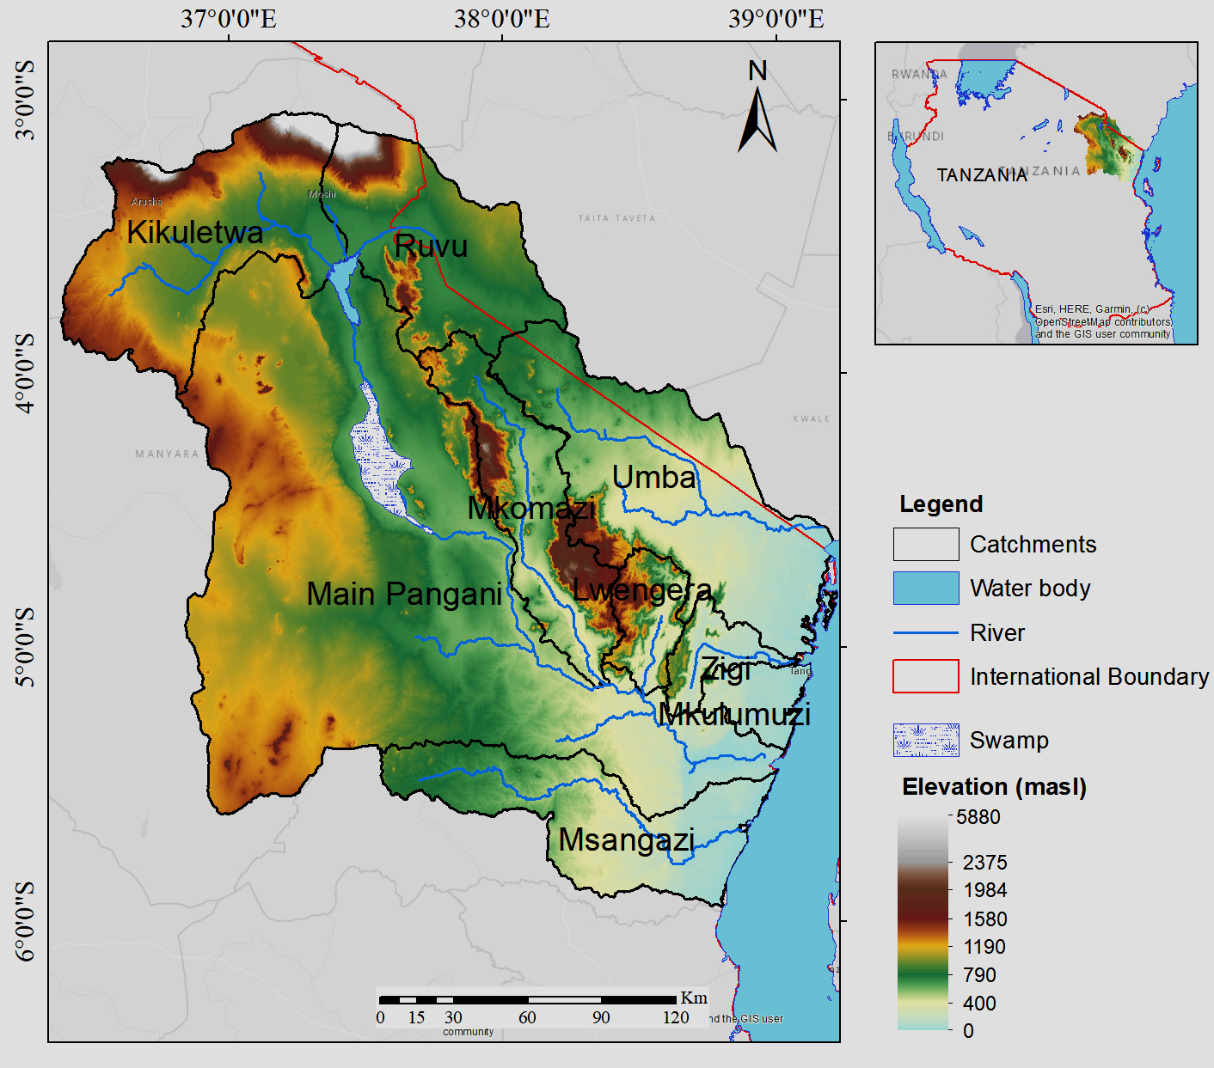
“Conservation of Water Sources is Our Collective Responsibility”
Issued By:
Pangani Basin Water Board
20 Old Moshi Road, P.O. Box 7617, 25101 Mawenzi, Moshi-Kilimanjaro
basins.pangani@maji.go.tz/basins.pangani@panganibasin.go.tz
www.panganibasin.go.tz
Contact: +255 27 2752780/+255 739 120 400/0800110026 (TOLL FREE)
5th May, 2026

